**2016 Formula Hybrid Electrical System Form (ESF)**

INTRODUCTION

The goal of the ESF is to ensure that vehicles are as safe as possible, and that they comply with the Formula-Hybrid completion rules. The ESF is divided seven main sections:

1 – Overview

2 – Cables, Fusing & Grounding

3 – Isolation & Insulation

4 – Electric Tractive System

5 – Accumulator System

6 – Safety Controls and Indicators

7 – GLV System

The *Cables and Fusing,* and *Insulation and Isolation* sections are at the beginning of the ESF as these are the areas where teams most often have trouble in complying with FH rules.

A clear, concise ESF will help you to build a better car. It will also help you to pass tech testing as most common tech problems can be addressed before the car reaches the track.

IMPORTANT INSTRUCTIONS AND REQUIREMENTS

1. Every part of this ESF must be filled with content. If a section is not relevant to your vehicle, mark it as “N/A” and describe briefly why not.
2. Leave the written instructions in place and add your responses below them.
3. All figures and tables must be included. An ESF with incomplete tables or figures will be rejected.
4. The maximum length of a complete ESF is 100 pages.
5. Note that many fields ask for information that was submitted in your ESF-1. This information must be reentered – in some cases will be different than what was entered in ESF-1, which is OK.
6. When completed, this document must be converted to a pdf and submitted to: <http://formula-hybrid.com/uploads/>

Please submit any questions, corrections and suggestions for improvement to: <http://www.formula-hybrid.org/level2/support>

REVIEW PROCESS

Once submitted, your ESF will be reviewed by at least two FH reviewers. One will be the designated *primary reviewer* for your team.

Feedback on your ESF occurs through the Formula Hybrid upload system. You will receive emails via this system from your reviewers offering guidance and feedback. You will also submit revised versions of your ESF in this system. When you submit a revised ESF, please indicate the REVISION DATE AND LETTER (starting with Letter A) and which sections have been updated in the following table:

|  |  |
| --- | --- |
| REVISION DATE: | 3/6/16 |
| REVISION: (A, B, C, etc…) | B |
|  |  |
| Section | Revised (Yes / No) |
| 1 – Overview | Yes |
| 2 – Cables and Fusing | No |
| 3 – Insulation and Isolation | No |
| 4 – Electric Tractive System | No |
| 5 – Accumulator System | No |
| 6 – GLV System | No |
| 7 – Safety Controls and Indicators | No |
| 8 – Appendices / Datasheets | No |

TITLE PAGE

*Please include team logo, car picture, etc..*



|  |  |
| --- | --- |
| University Name: | Yale University |
| Team Name: | Bulldogs Racing |
| Car Number: | 213 |

**Main Team Contact for ESF related questions:**

|  |  |
| --- | --- |
| Name: | Philip Piper |
| e-mail: | philip.piper@yale.edu |

**Table of Contents**

TITLE PAGE iii

I List of Figures vi

II List of Tables vii

III List of Abbreviations 1

Section 1 Vehicle Overview 2

Section 2 Cables, Fusing & Grounding 7

2.1 Fusing & Overcurrent Protection 7

2.2 Component Fusing 8

2.3 System Wire Tables 9

2.4 Grounding System 10

2.5 Conductive Panel Grounding 10

Section 3 Isolation & Insulation 11

3.1 Separation of Tractive System and Grounded Low Voltage System 11

3.2 Isolation & Insulation 12

3.3 Conduit 12

3.4 Shielded dual-insulated cable 13

3.5 Firewall(s) 13

Section 4 Electric Tractive System 15

4.1 Motor(s) 15

4.2 Motor Controller 15

4.3 Tractive System Measurement Points (TSMP) 16

4.4 Pre-Charge circuitry 17

4.5 Discharge circuitry 19

4.6 HV Disconnect (HVD) 20

4.7 Accelerator Actuator / Throttle Position Sensor 20

4.8 Accelerator / throttle position encoder error check 21

Section 5 Accumulator System 22

5.1 Accumulator Pack 22

5.2 Cell description 23

5.3 Cell configuration 23

5.4 Segment Maintenance Disconnect 24

5.5 Lithium-Ion Pouch Cells 24

5.6 Cell temperature monitoring 26

5.7 Accumulator Isolation Relays (AIR) 27

5.8 Accumulator Management System (AMS) 27

5.9 Accumulator wiring, cables, current calculations 28

5.10 Accumulator indicator 28

5.11 Charging 29

5.12 Accumulator Container/Housing 30

Section 6 Safety Controls and Indicators 32

6.1 Shutdown Circuit 32

6.2 IMD 34

6.3 Reset / Latching for IMD and AMS 35

6.4 Shutdown System Interlocks 35

6.5 Tractive System Energized Light (TSEL) 35

6.6 Tractive System Voltage Present light (TSVP) 36

6.7 Ready-To-Drive-Sound (RTDS) 36

Section 7 GLV System 37

7.1 GLV System Data 37

Section 8 Appendices 38

# List of Figures

Figure 1 - Electrical System Block Diagram 3

Figure 2 - Drawings showing the vehicle from the front, top, and side 4

Figure 3 - Locations of all major TS components 4

Figure 4 - TSV Wiring Schematic 6

Figure 5 - TS and GLV separation 11

Figure 6 – Firewall CAD rendering 14

Figure 7 – Pre-charge circuit schematic 17

Figure 8 – Pre-charge circuit voltage vs. time graph 18

Figure 9 – Pre-charge circuit current vs. time graph 18

Figure 10 – Pre-charge circuit resistor power vs. time graph 18

Figure 11 – Cell stack schematic with segment maintenance disconnects 24

Figure 12 – RGD525 high temperature plastic datasheet 30

Figure 13 – Accumulator stack configuration 31

Figure 14 – Safety Shutdown Circuit Schematic 32

Figure 15 – Location of Shutdown Circuit Components 34

Figure 16 – IMD schematic with latching relay 35

Figure 17 – Appendix A of Formula Hybrid rules 38

# List of Tables

Table 1- General Electrical System Parameters 6

Table 2 - Fuse Table 7

Table 3 - Component Fuse Ratings 8

Table 4 - System Wire Table 9

Table 6 – List of Containers with TS and GLV wiring 12

Table 9 - Shielded Dual Insulated Cable Data 13

Table 10 - Motor Data 15

Table 11 - Motor Controller Data 16

Table 12 – TSMP Resistor Data 17

Table 13 - Data for the pre-charge resistor 19

Table 14 - Data of the pre-charge relay 19

Table 15 - Data of the discharge circuit. 20

Table 16 - Throttle Position encoder data 20

Table 17 - Main accumulator parameters 22

Table 18 - Main cell specification 23

Table 19 - SMD Data 24

Table 20 - Cell Temperature Monitoring 27

Table 21 - AIR data 27

Table 22 - AMS Data 27

Table 23 - Charger data 29

Table 24 - Switches& devices in the shutdown circuit 33

Table 25 - Shutdown circuit Current Draw 33

Table 26 Parameters of the IMD 34

Table 27- GLV System Data 37

# List of Abbreviations

AIR Accumulator Isolation Relay

AMS Accumulator Management System

FH Rules Formula Hybrid Rule

GLV Grounded Low-Voltage

IMD Insulation Monitoring Device

SMD Segment Maintenance Disconnect

TS Tractive System

TSEL Tractive System Energized Light

TSMP Tractive System Measurement Point

TSV Tractive System Voltage

TSVP Tractive System Voltage Present

BMS Battery Management System (equivalent to AMS)

GFD Ground Fault Detector (equivalent to IMD)

GLVMS Grounded Low Voltage Master Switch

TSMS Tractive System Master Switch

# Vehicle Overview

Person primarily responsible for this section:

|  |  |
| --- | --- |
| Name: | Philip Piper |
| e-mail: | philip.piper@yale.edu |

Check the appropriate boxes:

**Vehicle is**

New (built on an entirely new frame)

New, but built on a pre-existing frame (FSAE, FS, FH-HIP, FH electric-only, etc.)

Updated from a previous year vehicle

**Architecture**

Hybrid

Series

Parallel

Hybrid in Progress (HIP)

Electric-only

**Drive**

Front wheel

Rear wheel

All-wheel

**Regenerative braking**

Front wheels

Rear wheels

All wheels

None

NARRATIVE OVERVIEW

*Provide a brief, concise description of the vehicles main electrical systems including tractive system, accumulator, hybrid type (series or parallel) and method of mechanical coupling to wheels. Describe any innovative or unusual aspects of the design.*

Bulldogs Racing’s 2016 car, BR2016, is built around an independent rear wheel drive system consisting of two motors. These motors are coupled through two planetary gearboxes for a compact, linear drivetrain. This allows for the accumulator to be placed directly behind the center of gravity of the vehicle on the car centreline, improving vehicle dynamics properties greatly over a side pod orientation. The accumulator is made of a solid steel construction protecting 86 lithium iron pouch cells split into four separate stacks. This vehicle was designed to have maximal power output for acceleration and autocross while keeping the motor’s in their most efficient regime for the endurance speeds posted in the rules.

Include the following figures:

* **Figure 1** – an electrical system block diagram showing all major parts associated with the tractive-system. (Not detailed wiring).
* **Figure 2** – Drawings or photographs showing the vehicle from the front, top, and side
* **Figure 3** – A wiring diagram superimposed on a top view of the vehicle showing the locations of all major TS components and the routing of TS wiring.
* **Figure 4** -- Include a complete TSV wiring schematic per FH Rule **S4.4.1** showing connections between all TS components. This should include accumulator cells, AIRs, SMDs, motor controller, motor, pre-charge and discharge circuits, AMD, IMD, charging port and any other TS connections. **NOTE:** Figure 4 is the most important diagram in the ESF

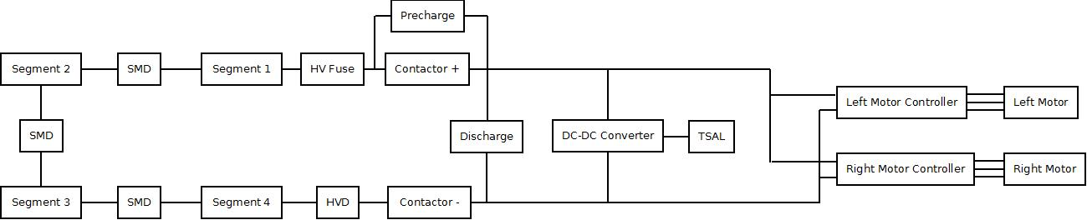

Figure 1 - Electrical System Block Diagram

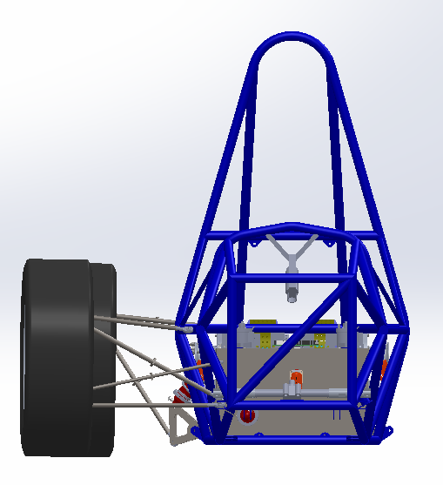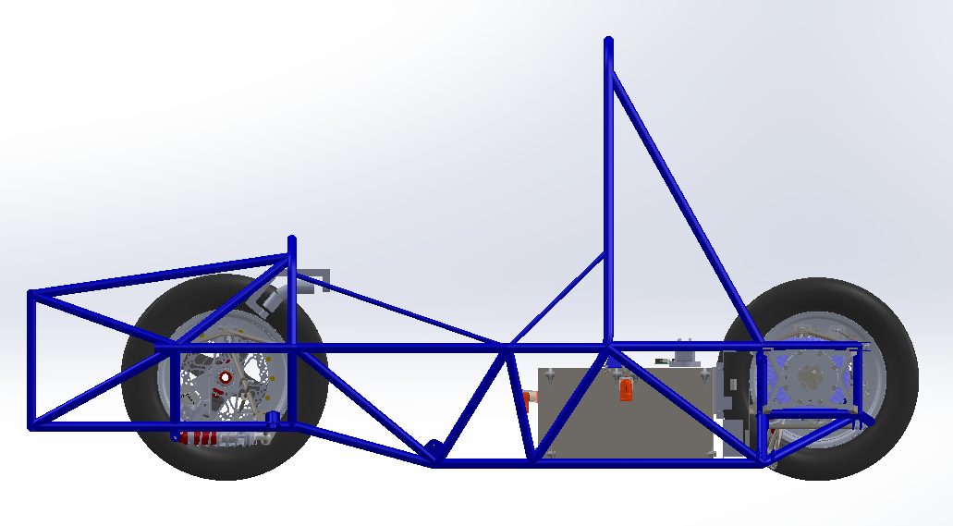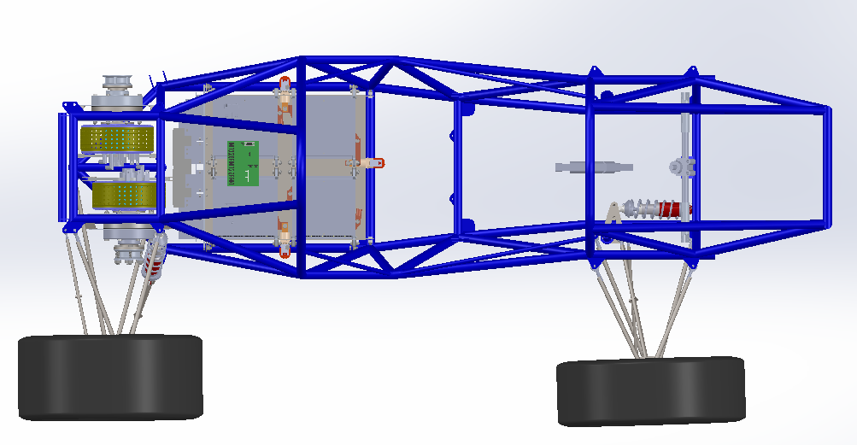

Figure 2 - Drawings showing the vehicle from the front, top, and side

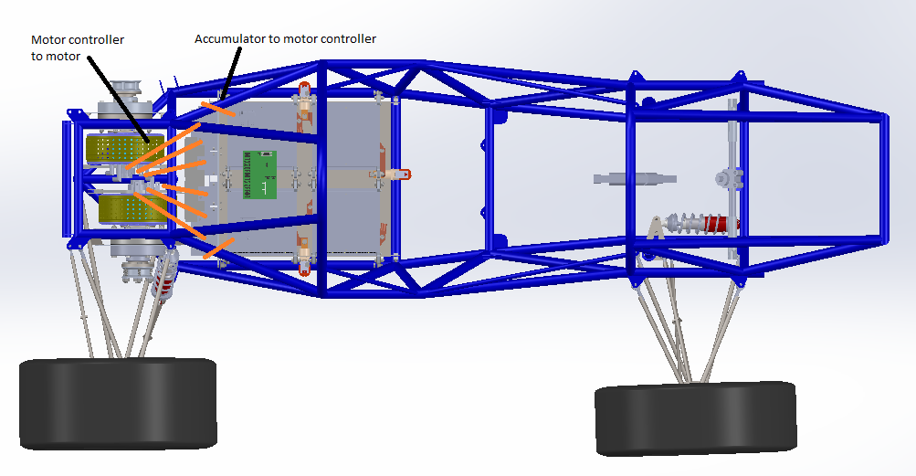

Figure 3 - Locations of all major TS components

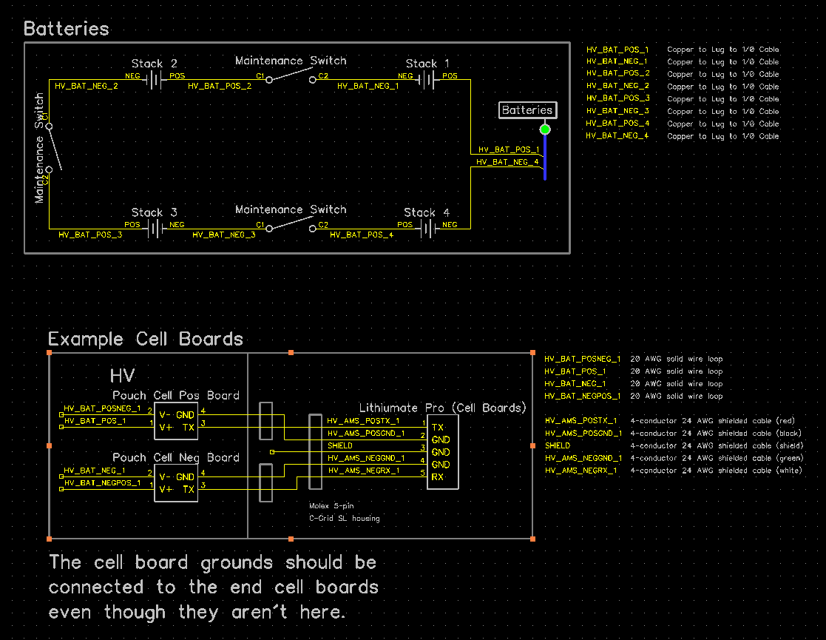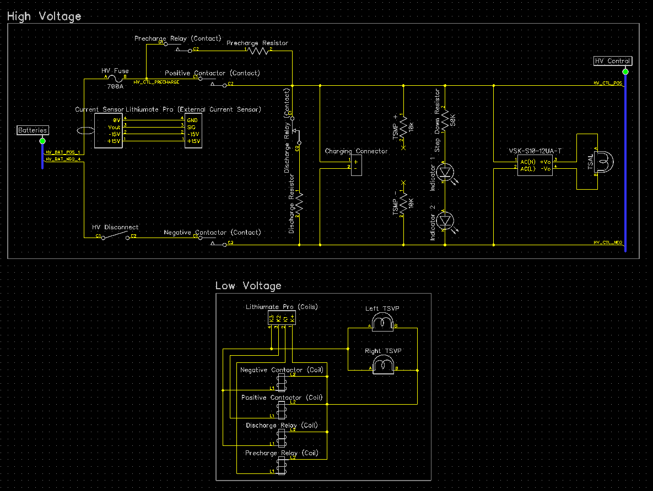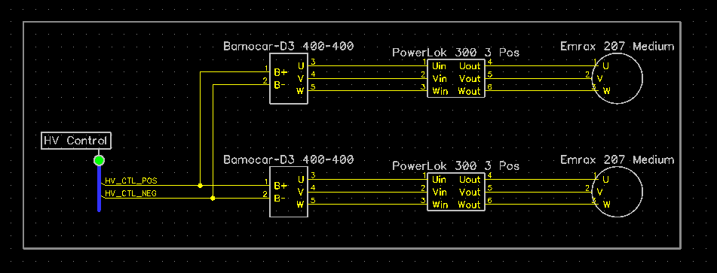

Figure 4 - TSV Wiring Schematic

Fill in the following table:

|  |  |
| --- | --- |
| Item | Data |
| Nominal Tractive System Voltage (TSV) | 283.8 VDC |
| Max. TSV (typically this is during charging) | 300 VDC |
| Control System voltage (GLV) | 12 VDC |
| Total Accumulator capacity (Wh)[1] | 4540.8 Wh |
| Accumulator type (Lead-acid, Li-Ion, NiMH, Ultracap..) | Li-Ion (LiFePO4) |
| Number of electric motors, total | 2 |
| Are wheel motors used? | Yes /  No |

Table 1- General Electrical System Parameters

# Cables, Fusing & Grounding

Person primarily responsible for this section:

|  |  |
| --- | --- |
| Name: | Philip Piper |
| e-mail: | philip.piper@yale.edu |

## Fusing & Overcurrent Protection

*List TS and GLV fuse (or circuit breaker) data, and where used*

|  |  |  |  |  |  |
| --- | --- | --- | --- | --- | --- |
| Mfg. | Fuse Part Number | Cont. Rating (A) | DC Voltage Rating | DC Interrupt Rating (A) | Where Used |
| Littelfuse | L50S200 | 200 | 450 | 20000 | HV Accumulator |
| Littelfuse | ATOF Blade Fuse | 2 | 32 | 1000 | Microcontroller |
| Littelfuse | ATOF Blade Fuse | 1 | 32 | 1000 | Brake Light |
| Littelfuse | ATOF Blade Fuse | 1 | 32 | 1000 | Pedal Box |
| Littelfuse | ATOF Blade Fuse | 1 | 32 | 1000 | Dashboard |
| Littelfuse | ATOF Blade Fuse | 1 | 32 | 1000 | Buzzer |
| Littelfuse | ATOF Blade Fuse | 1 | 32 | 1000 | Transceiver |
| Littelfuse | ATOF Blade Fuse | 1 | 32 | 1000 | AMS |
| Littelfuse | ATOF Blade Fuse | 2 | 32 | 1000 | Left Motor Controller |
| Littelfuse | ATOF Blade Fuse | 2 | 32 | 1000 | Right Motor Controller |
| Littelfuse | ATOF Blade Fuse | 7.5 | 32 | 1000 | LV Fuse |
| Littelfuse | ATOF Blade Fuse | 2 | 32 | 1000 | HV Indicators |
| Littelfuse | ATOF Blade Fuse | 4 | 32 | 1000 | Contactor Coils |

Table 2 - Fuse Table

## Component Fusing

*List major components (e.g., motor controller, dc-dc converter) and data sheet max fuse rating. Ensure that the rating of the fuse used is less than the maximum value for the component*

|  |  |  |  |  |
| --- | --- | --- | --- | --- |
| Component | Fuse Part Number | Max Fuse Rating A | Installed Fuse Rating A | Notes |
| Bamocar D3 400-400 | ATOF Blade Fuse | N/A | 2 | Unlisted. Continuous and maximum current tested |
| eLithion Lithiumate Pro | ATOF Blade Fuse | N/A | 1 | Unlisted. Continuous and maximum current tested |
| Microcontroller | ATOF Blade Fuse | N/A | 2 | Unlisted. Continuous and maximum current tested |
| Contactor | ATOF Blade Fuse | N/A | 4 | Unlisted. Continuous and maximum current tested |

Table 3 - Component Fuse Ratings

## System Wire Tables

*List wires and cables used in the Tractive System and the GLV system - wires protected by a fuse of 1 A or less may be omitted.*

*Cable capacity is the value from FH Rules* ***Appendix E*** *(Wire Current Capacity). A revised version of* ***Appendix E*** *that includes metric wire sizes is available at the FH web site. Show available fault current and how calculated. Available fault current can be calculated from $Fault Current= Vsource / (Rsource + Rwiring)$*

|  |  |  |  |  |  |  |  |  |  |  |  |
| --- | --- | --- | --- | --- | --- | --- | --- | --- | --- | --- | --- |
| Mfg. | Part Number | Size AWG / mm2 | Insulation Type | Voltage Rating | Temp. Rating C | Cable Capacity A | Fuse Part # | Fuse Cont. A | Fuse Interr-upting Rating Adc | Avail. Fault Current A | Where Used & How fault current is calculated |
| Amphenol | AC-CP700160 | 50 | XLPE Orange | 1500 | 125 | 200 | L50S200 | 200 | 20000 | 3459 | Tractive system calculated using 0.086 Ohm source resistance and 2m cable |
| Alpha Wire | 2403C SL005 | 22 | PVC | 150 | 75 | 7 | ATOF Blade Fuse | 2 | 1000 | 228 | Motor controller power calculated using 0.1 Ohm source resistance and 6ft cable |
| Alpha Wire | 2241C SL005 | 18 | PVC | 300 | 80 | 14 | ATOF Blade Fuse | 7.5 | 1000 | 36 | Shutdown circuit calculated using 0.1 Ohm source resistance and 20ft cable |
| Alpha Wire | 2403C SL005 | 22 | PVC | 150 | 75 | 7 | ATOF Blade Fuse | 2 | 1000 | 3 | HV indicators calculated using 4 Ohm source resistance and 4ft cable |
| Alpha Wire | 2403C SL005 | 22 | PVC | 150 | 75 | 7 | ATOF Blade Fuse | 4 | 1000 | 228 | Contactor coils calculated using 0.1 Ohm source resistance and 6ft cable |
| Alpha Wire | 2403C SL005 | 22 | PVC | 150 | 75 | 7 | ATOF Blade Fuse | 2 | 1000 | 496 | Microcontroller calculated using 0.1 Ohm source resistance and 2ft cable |

Table 4 - System Wire Table

## Grounding System

*Describe how you keep the resistances between accessible components below the required levels as defined in FH Rules* ***EV4.3****. If wire is used for ground bonding, state the AWG or mm2 of the wire*

Most if not all accessible components are kept grounded by steel bolts to steel tabs welded to the chassis. Additionally, a 12 AWG cable will directly ground the negative pole of the LV battery to the chassis.

## Conductive Panel Grounding

*If carbon fiber or coated conductive panels are used in your design, describe the fabrication methods used to ensure point to point resistances that comply with* ***EV4.3.2****. Describe results of measurements made per* ***EV4.3.3****.*

All carbon fiber components on the car are directly bolted to steel tabs on the chassis at multiple points to ensure that they are properly grounded. These components include the nosecone, seat, floor closeout panels, and accumulator covers. These carbon fiber components are currently being manufactured, and therefore haven’t been tested for conductivity yet.

# Isolation & Insulation

Person primarily responsible for this section:

|  |  |
| --- | --- |
| Name: | Philip Piper |
| e-mail: | philip.piper@yale.edu |

## Separation of Tractive System and Grounded Low Voltage System

*Describe how the TS and GLV systems are physically separated (****EV4.1****). Add CAD drawings or photographs of how TS and GLV are segregated in key areas of the electrical system.*

The tractive system and grounded low voltage systems are physically separated in the accumulator. The 86 tractive system cells are completely enclosed in a steel accumulator. The AMS communication wires are the only GLV wires that enter this part of the accumulator. The contactors and AMS are connected to the top of the accumulator box. These are bolted to the surface of the box such that they are properly isolated from each other.

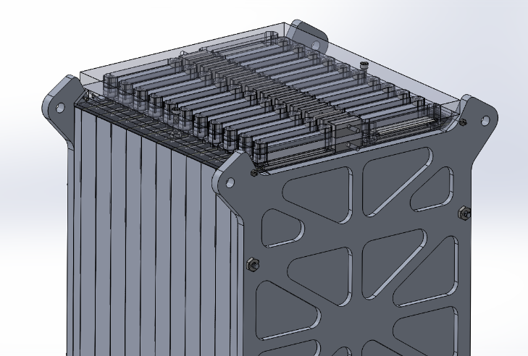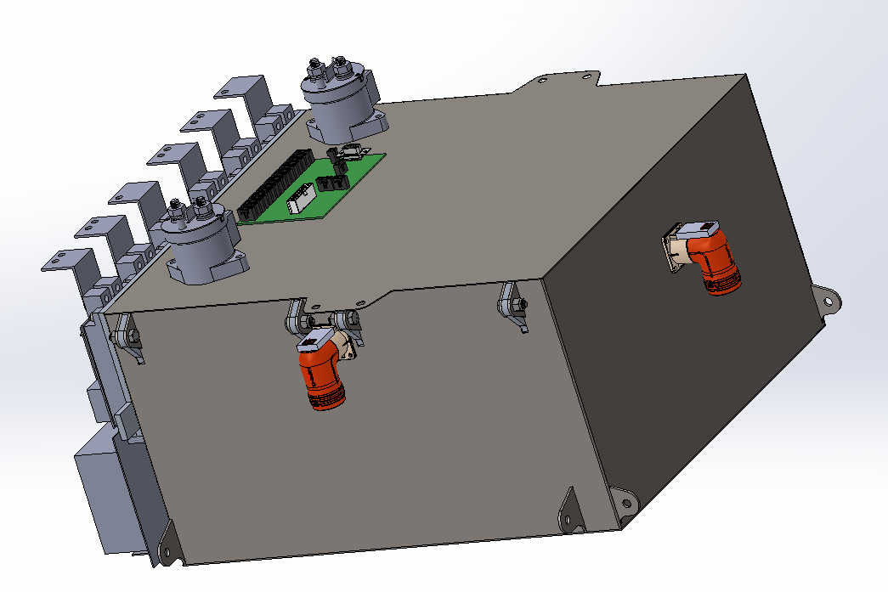

Figure 5 - TS and GLV separation

*List all electrical circuit boards designed by team that contain TS and GLV voltage in the following table.*

None

*Add a figure (board layout drawing) for each team-designed PCB showing that spacings comply with* ***EV4.1.8***

None

*List all purchased components with both TS and GLV connections (at min motor controller and AMS)*

|  |  |  |  |
| --- | --- | --- | --- |
| Component | Isolation Method | Link to Document Describing Isolation | Notes |
| Left Motor Controller | Optoisolator | <http://www.unitek-online.de/pdf/download/Antriebe-Drive/BAMOCAR/E-BAMOCAR-D3.pdf> |  |
| Right Motor Controller | Optoisolator | <http://www.unitek-online.de/pdf/download/Antriebe-Drive/BAMOCAR/E-BAMOCAR-D3.pdf> |  |
| Contactor | Magnetic | <http://www.rec-bms.com/datasheet/Technical_datasheet_Kilovac.pdf> |  |
| Pre-Charge Relay | Magnetic | <https://www.components.omron.com/components/web/pdflib.nsf/0/8F66C9A835A195FE85257201007DD572/$file/G2RL_0911.pdf> |  |
| Discharge Relay | Magnetic | <https://www.components.omron.com/components/web/pdflib.nsf/0/8F66C9A835A195FE85257201007DD572/$file/G2RL_0911.pdf> |  |
| DC-DC Regulator | Magnetic | <http://www.mouser.com/ds/2/670/vsk-s3-520566.pdf> |  |

## Isolation & Insulation

*Provide a list of containers that have TS and GLV wiring in them. If a barrier is used rather than spacing, identify barrier material used (reference* ***Error! Reference source not found.****).*

|  |  |  |  |  |  |
| --- | --- | --- | --- | --- | --- |
| Container Name | Segregation by Spacing (Y or N) | How is Spacing maintained | Actual Measured Spacing mm | Alt – Barrier Material P/N | Notes |
| Accumulator | Y | Components bolted | 25.4 | N/A |  |

Table 5 – List of Containers with TS and GLV wiring

*List all insulating barrier materials used to meet the requirements of* ***EV1.3*** *or* ***EV4.1.5***

None

## Conduit

*List different types of conduit used in the design. Specify location and if manufacturer’s standard fittings are used. Note Virtual Accumulator Housing FH Rules* ***EV3.3.1*** *requires METALLIC type LFMC.*

No conduits are used

*Describe how the conduit is anchored if standard fittings are not used.*

None

*Is all conduit contained within the vehicle Surface Envelope per* ***EV4.2.1****? (****Y or N****).*

*Does all conduit comply with* ***EV4.5.10****? (****Y or N****).*

N/A

## Shielded dual-insulated cable

*If Shielded, dual-insulated cable per EV4.5.8 used in the vehicle, provide specifications and where used:*

|  |  |  |  |  |
| --- | --- | --- | --- | --- |
| MFR | Part Number | Cross Section mm2 | Shield grounded at both ends (Y or N) | Location / Use |
| Amphenol | AC-CP700500 | 50 | Y | Motor controllers to motors |

Table 6 - Shielded Dual Insulated Cable Data

## Firewall(s)

#### Description/materials

*Describe the concept, layer structure and the materials used for the firewalls. Describe how all firewall requirements in FH Rules* ***T4.5.1*** *are satisfied. Show how the low resistance connection to chassis ground is achieved.*

A 1/16” sheet of aluminum is used for the firewall. The seat belt attaches in front of the firewall, and aluminum tape is used to close out the firewall to the frame where necessary. The firewall additionally extends high enough to meet T4.5.5. Note that the CAD rendering below shows a firewall version that is a little shorter than what we will be using.

#### Position in car

*Provide CAD-rendering or photographs showing the location of the firewall(s).*

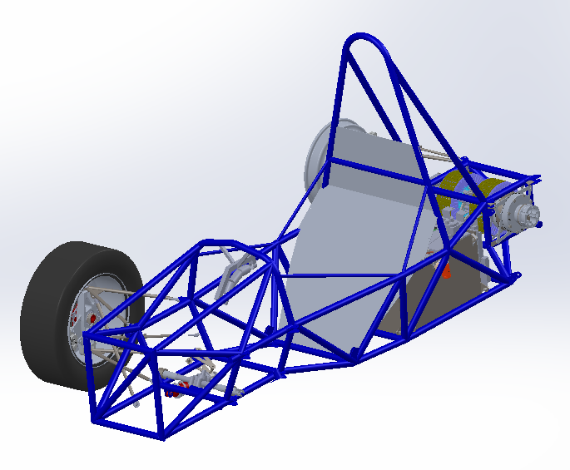

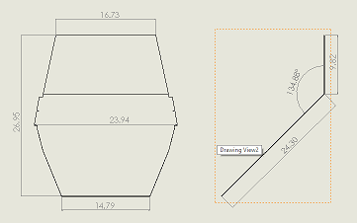

Figure 6 – Firewall CAD rendering

# Electric Tractive System

Person primarily responsible for this section:

|  |  |
| --- | --- |
| Name: | Philip Piper |
| e-mail: | philip.piper@yale.edu |

## Motor(s)

*Describe the motor(s) used and reason for this particular choice. Add additional tables if multiple motor types are used*

|  |  |
| --- | --- |
| Manufacturer and Model: | Enstroj Emrax 207 Medium |
| Motor type (PM, Induction, DC Brush..) | PM |
| Number of motors of this type used | 2 |
| Nominal motor voltage (Vrms l-l or Vdc) | 300VDC battery voltage specified in datasheet |
| Nominal / Peak motor current (A or A/phase) | Nom: 160Arms / Peak: 320Arms |
| Nominal / Peak motor power | Nom: 30kW / Peak: 80kW |
| Motor wiring – conductor size and type | 50mm^2 double insulated |

Table 7 - Motor Data

*Provide calculations for currents and voltages. State how this relates to the choice of cables and connectors used.*

The motors will not be run at more than 100A nominally due to the constraints of the accumulator design. However, it will be run at 300A peak. Therefore, 50mm^2 wire was chosen to meet the AC current carrying capacity of 100Arms as described in the *Handbook of Electronic Tables and Formulas*.

## Motor Controller

*Describe the motor controller(s) used and reason for this particular choice. Add additional tables if multiple motor controller types are used.*

Two Bamocar D3 400-400 motor controllers are used to control two Emrax 207 Medium motors. The Bamocars can use up to 400A from a 400V DC bus. We will be using a 300V DC bus at a maximum of 600A (300A per motor controller). This design removes the need for a differential, and has fantastic performance in terms of maximum acceleration and efficiency.

|  |  |
| --- | --- |
| Manufacturer and Model: | Unitek Bamocar D3 400-400 |
| Number of controllers of this type used | 2 |
| Maximum Input voltage: | 400 VDC |
| Nominal Input Current (A) | 400 A |
| Max Input Fuse (A) per Mfr. | Not specified (200A continuous used) |
| Output voltage (Vac l-l or Vdc) | Not specified |
| Isolation voltage rating between GLV (power supply or control inputs) and TS connections | Not specified other than “galvanic isolation between power connection, motor connection, and all other control connections. |
| Is the accelerator galvanically isolated from the Tractive System per **EV2.3**? | Yes /  No |

Table 8 - Motor Controller Data

*If the answer to the last question is NO, how to you intend to comply with rule* ***EV2.3*** *(an external isolator is acceptable)..*

Not applicable

*Provide calculations for currents and voltages. State how this relates to the choice of cables and connectors used.*

50mm^2 cable is used at the output of the motor controllers as described earlier. This was chosen according to a standard engineering handbook. The input of the motor controller is connected to with copper bus bars.

## Tractive System Measurement Points (TSMP)

*The TSMP must comply with FH Rule* ***EV4.4****. Describe the TSMP housing and location. Describe TSMP electrical connection point.*

The TSMP is housed in a 4mm safety banana jack next to the GLV and TS master switches.

|  |  |
| --- | --- |
| TSMP Output Protection Resistor Value | 10 kΩ |
| Resistor Voltage Rating | 450 V |
| Resistor Power Rating | 10 W |

Table 9 – TSMP Resistor Data

## Pre-Charge circuitry

*Describe your design for the pre-charge circuitry. Describe wiring, connectors and cables used.*

The pre-charge circuit is used to charge the motor controller capacitors up to the DC bus voltage with a current that won’t harm the accumulator, or trip the main TS fuse. Each of our two motor controllers has a capacitance of 800uF for a total of 1600uF (we checked the capacitor values and measured it). A normally open relay contact and resistor are connected in parallel with the positive accumulator isolation relay such that it can be bypassed, providing a current to charge the motor controller capacitors. A maximum of about 0.3A is used so the wiring uses 300V 22 gauge wire. Anderson Powerpole connectors are used to connect the resistor to the relay and the pre-charge circuit to the rest of the high voltage circuitry.

* *Include a schematic of the pre-charge circuit*

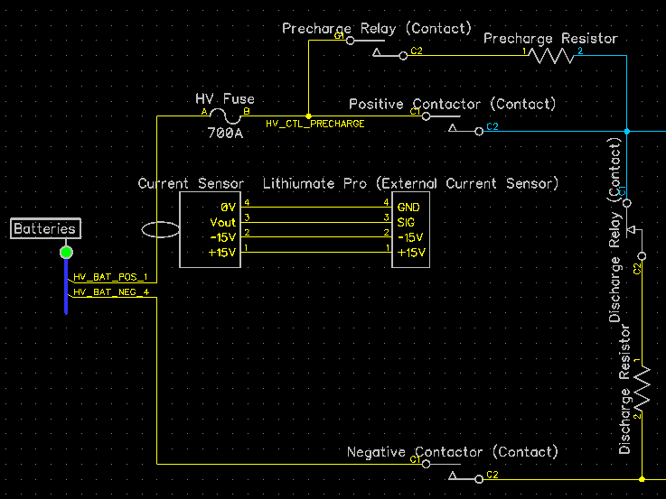

Figure 7 – Pre-charge circuit schematic

* *Include a plot of calculated TS Voltage vs. time*

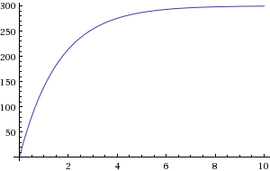

Figure 8 – Pre-charge circuit voltage vs. time graph

* *Include a plot of calculated Current vs. time*

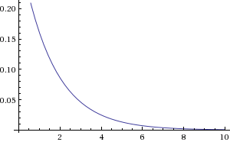

Figure 9 – Pre-charge circuit current vs. time graph

* *Include a plot of resistor power vs time.*

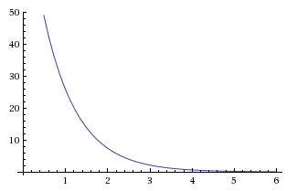

Figure 10 – Pre-charge circuit resistor power vs. time graph

*Provide the following information:*

|  |  |
| --- | --- |
| Resistor Type: | Ohmite 20 Series Resistor |
| Resistance: | 1kΩ |
| Continuous power rating: | 10W |
| Overload power rating: | 100 W for 10 sec |
| Voltage rating: | 720 V |

Table 10 - Data for the pre-charge resistor

|  |  |
| --- | --- |
| Relay MFR & Type: | Omron G2RL |
| Contact arrangement (e.g. SPDT) | SPDT |
| Continuous DC contact current (A): | 8 A |
| Contact voltage rating (Vdc). | 300 V |

Table 11 - Data of the pre-charge relay

## Discharge circuitry

*Describe your concept for the discharge circuitry. Describe wiring, connectors and cables used.*

The discharge circuit is a normally closed circuit that discharges voltage from the motor controller input capacitors when the AIRs are opened. This prevents high voltages from lingering on the tractive system wires when the car is turned off. Each of our two motor controllers has a capacitance of 800uF for a total of 1600uF (we checked the capacitor values and measured it). A discharge relay contact and resistor in series are bridged between the tractive system positive and negative lines. The relay is normally closed, and is opened whenever normal operation of the vehicle takes place.

* *Include a schematic of the dis-charge circuit*
* *Include a plot of calculated TS Voltage vs. time*

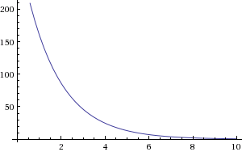

Figure 11 – Discharge Voltage (v) vs. Time (s)

* *Include a plot of calculated “Discharge current” vs. time*



Figure 12 - Discharge Current (A) vs. Time (s)

* *Include a plot of resistor power vs time.*

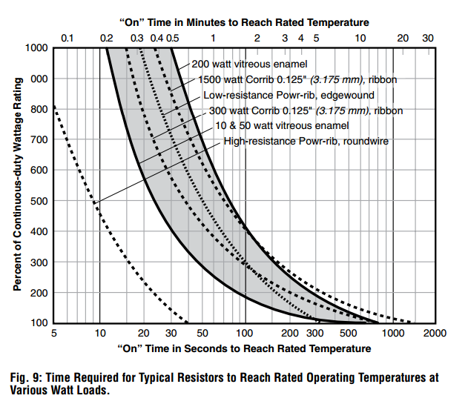

Figure 13 - Manufacturer discharge resistor power vs. time until max temperature curve

*Provide the following information:*

|  |  |
| --- | --- |
| Resistor Type: | Ohmite 20 Series Resistor |
| Resistance: | 1 kΩ (2 2kOhm in parallel) |
| Continuous power rating: | 10 W |
| Overload power rating: | 100 W for 5 sec |
| Voltage rating: | 720 V |
| Maximum expected current: | 0.3 A |
| Average current: | ~ 0.1 A |

Table 12 - Data of the discharge circuit.

## HV Disconnect (HVD)

*Describe your design for the HVD and how it is operated, wiring, and location. Describe how your design meets all requirements for* ***EV4.7***

The HV disconnect is placed on top of the accumulator such that it is easily accessible to pit crew and safety workers. It is placed just before the negative AIR, and therefore cuts off current to both motor controllers. It must be able to break up to 600A peak current (assuming the car is stalled against a wall pulling full torque and needs to be turned off). No tools are needed to operate the HVD. More specifically the HVD is a 300 series Amphenol PowerLok connector connected to a 50mm^2 PowerLink HV cable.

## Accelerator Actuator / Throttle Position Sensor

*Describe the accelerator actuator and throttle position sensor(s) used, describe additional circuitry used to check or condition the signal going to the motor controller. Describe wiring, cables and connectors used. Provide schematics and a description of the method of operation of any team-built signal conditioning electronics. Explain how your design meets all of the requirements of FH Rules* ***IC1.6*** *and* ***EV2***

Two Novotechnik linear potentiometers are used on the throttle pedal in parallel to measure the driver’s throttle request. This signal is passed through a microcontroller to determine if the two signals vary significantly from a high and low preset, and to check if the two signals vary significantly from each other. If either of these two cases occur, then the microcontroller immediately shuts off the TS through a relay. Galvanic isolation of the acceleration signal sent from the microcontroller to the motor controller is achieved by the motor controller itself. 22 gauge wires are used for all of these signal connections because they do not carry currents over 100mA.

|  |  |
| --- | --- |
| Actuator / Encoder manufacturer and model: | Novotechnik TX2 Series |
| Encoder principle (e.g.Potentiometer): | Linear Potentiometer |
| Output: | Voltage |
| Is motor controller accelerator signal isolated from TSV? | Yes /  No |
| If no, how will you satisfy rule **EV2.3**? | N/A |

Table 13 - Throttle Position encoder data

## Accelerator / throttle position encoder error check

*Describe how the system reacts if an error (e.g. short circuit or open circuit or equivalent) is detected. Describe circuitry used to check or condition the signal going to the motor controller. Describe how failures (e.g. Implausibility, short circuit, open circuit etc.) are detected and how the system reacts if an error is detected. State how you comply with* ***EV2.2***

### The microcontroller reacts to a short circuit or open circuit first by detecting this fault through the use of known accelerator bounds and a pull down resistor which is located on the ECU PCB, just behind the driver. Upon a fault, the microcontroller shuts down the tractive system through a relay that cuts power to the AIR coils. Implausibility is also checked in a control loop by comparing the two throttle potentiometer sensor values to each other, and cutting off the AIRs if they vary by more than 5%.

# Accumulator System

Person primarily responsible for this section:

|  |  |
| --- | --- |
| Name: | Philip Piper |
| e-mail: | philip.piper@yale.edu |

## Accumulator Pack

*Provide a narrative design of the accumulator system and complete the following table.*

The accumulator is designed to meet all of the requirements of the Formula Hybrid and Formula Electric rules. Lithium iron pouch cells are used because they fit the Bamocar-Emrax system well, and they are safer than lithium cobalt based batteries in terms of puncture and thermal runaway.

|  |  |
| --- | --- |
| Maximum Voltage (during charging): | 300 VDC |
| Nominal Voltage: | 283.8 VDC |
| Total number of cells: | 86 |
| Cell arrangement (x in series / y in parallel): | 86 in series / 1 in parallel |
| Are packs commercial or team constructed? | Commercial /  Team |
| Total Capacity (per FH Rules **Appendix A**): | 4540.8 kWh |
| Maximum Segment Capacity | 5227.2 MJ |
| Number of Accumulator Segments | 4 |

Table 14 - Main accumulator parameters

*Describe how pack capacity is calculated. Provide calculation at 2C (0.5 hour) rate? How is capacity derived from manufacturer’s data? If so, include discharge data or graph here. Include Peukert calculation if used (See FH Rules* ***Appendix A****)*

Pack capacity is calculated from the nominal cell capacity provided by A123 Systems.

*Show your segment energy calculations. The segment energy is calculated as*

$$Vnom x Cell AH \left(2C rate\right) x Number of Cells x 3.6 \left(kJ\right)$$

3.3V x 20Ah x 22 cells x 3.6kJ/kWh = 5227.2kJ

(The 80% factor is not applied for this calculation.)

## Cell description

*Describe the cell type used and the chemistry and complete the following table.*

A pouch style lithium iron cell is used, provided by A123 Systems.

|  |  |
| --- | --- |
| Cell Manufacturer and Model | A123 Amp20 |
| Cell type (prismatic, cylindrical, pouch, etc.) | Yes /  No |
| Are these pouch cells | Yes /  No |
| Cell nominal capacity at 2C (0.5 hour) rate: | 20 Ah |
| Data sheet nominal capacity | 20 Ah at 0.5 C rate |
| Maximum Voltage (during charging): | 3.488 V |
| Nominal Voltage (data sheet value): | 3.3 V |
| Minimum Voltage (AMS setting): | 2.0 V |
| Maximum Cell Temperature (charging - AMS setting) | 60 °C |
| Maximum Cell Temperature (discharging - AMS setting) | 60 °C |
| Cell chemistry: | LiFePO4 |

Table 15 - Main cell specification

*Show your calculations for 2C nominal AH capacity if the data sheet uses a different discharge rate. Refer to FH rules* ***Appendix A***

N/A

## Cell configuration

*Describe cell configuration, show schematics, cover additional parts like internal cell fuses etc.*

*Describe configuration: e.g., N cells in parallel then M packs in series, or N cells in series then M strings in series.*

The cells are configured such that 86 cells are in series with 1 cell in parallel. Cell boards are placed in between the cell tabs to accurately measure temperature and voltage through a centralized accumulator management system.

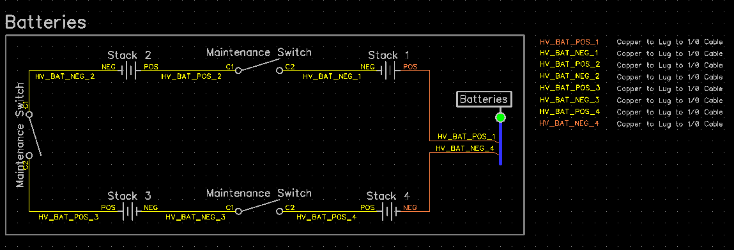

Figure 14 – Cell stack schematic with segment maintenance disconnects

*Does the accumulator combine individual cells in parallel without cell fuses?* Yes /  No

*If Yes, explain how* ***EV6.1.7*** *is satisfied.*

N/A

## Segment Maintenance Disconnect

*Describe segment maintenance disconnect (SMD) device, locations, ratings etc.*

|  |  |
| --- | --- |
| Is HVD used as an SMD? | Yes /  No |
| Number of SMD Devices | 3 |
| SMD MFR and Model | Amphenol PowerLok |
| SMD Rated Voltage (if applicable) | 1000 VDC |
| SMD Rated Current (if applicable) | 200 A continuous |
| Segment Energy (6 MJ max) | 5227.2 MJ |
| Segment Energy Discharge Rate (Ref FH Rules **Appendix A**) | 2 C |

Table 16 - SMD Data

## Lithium-Ion Pouch Cells

*The vehicle accumulator uses individual pouch cells.* Yes  No

Note that designing an accumulator system utilizing pouch cells is a substantial engineering undertaking which may be avoided by using prismatic or cylindrical cells.

*If your team has designed your accumulator system using individual Lithium-Ion pouch cells, include drawings, photographs and calculations demonstrating compliance with all sections of rule* ***EV3.9.*** *If your system has been issued a variance to* ***EV3.9*** *by the Formula Hybrid rules committee, include the required documentation from the cell manufacturer.*

EV3.9.1 – Pouches are arranged in two 22 and two 21 cell face-to-face stacks.

EV3.9.2 – Aluminum end plates and four aluminum threaded rods mechanically restrain the stack in one axis to a set length. Foam filler compresses as the cells expand to keep the cell face pressure within 4 to 18 psi, as suggested by the manufacturer A123. Distorted thread lock nuts are used to meet the temperature requirement of EV3.9.2(a) and EV3.9.2(c). A123 states that the cells will expand by 1% during regular cycling, and 3-5% during the cell’s lifetime. The stack length set point is determined on the last line in the “Avg stack thickness (mm)” column. Note that the filler is chosen such that the “Total cell expansion (mm)” is less than the “Total filler expansion (mm)”.

|  |  |  |  |  |
| --- | --- | --- | --- | --- |
| **Even Stack** |  |  | **Odd Stack** |  |
| Cells |  |  | Cells |  |
| Number of cells | 22 |  | Number of cells | 21 |
| Cell thickness (mm) | 7.1 |  | Cell thickness (mm) | 7.1 |
| Min cell expansion (%) | 1 |  | Min cell expansion (%) | 1 |
| Max cell expansion (%) | 6 |  | Max cell expansion (%) | 6 |
| Min cells thickness (mm) | 157.762 |  | Min cells thickness (mm) | 150.591 |
| Max cells thickness (mm) | 165.572 |  | Max cells thickness (mm) | 158.046 |
| Total cell expansion (mm) | 7.81 |  | Total cell expansion (mm) | 7.455 |
|  |  |  |  |  |
| Heat Spreaders |  |  | Heat Spreaders |  |
| Number of heat spreaders | 12 |  | Number of heat spreaders | 11 |
| Heat spreader thickness (mm) | 0.508 |  | Heat spreader thickness (mm) | 0.508 |
| Total thickness (mm) | 6.096 |  | Total thickness (mm) | 5.588 |
|  |  |  |  |  |
| Kapton Tape |  |  | Kapton Tape |  |
| Number of Kapton tapes | 24 |  | Number of Kapton tapes | 22 |
| Kapton tape thickness (mm) | 0.0762 |  | Kapton tape thickness (mm) | 0.0762 |
| Total thickness (mm) | 1.8288 |  | Total thickness (mm) | 1.6764 |
|  |  |  |  |  |
| End Plate |  |  | End Plate |  |
| Number of end plates | 2 |  | Number of end plates | 2 |
| End plate thickness (mm) | 6.35 |  | End plate thickness (mm) | 6.35 |
| Total thickness (mm) | 12.7 |  | Total thickness (mm) | 12.7 |
|  |  |  |  |  |
| Filler |  |  | Filler |  |
| Number of fillers | 10 |  | Number of fillers | 9 |
| Filler thickness (mm) | 1.5875 |  | Filler thickness (mm) | 1.5875 |
| 4psi expansion (%) | 0 |  | 4psi expansion (%) | 0 |
| 18psi expansion (%) | 55 |  | 18psi expansion (%) | 55 |
| Min filler thickness (mm) | 15.875 |  | Min filler thickness (mm) | 14.2875 |
| Max filler thickness (mm) | 24.60625 |  | Max filler thickness (mm) | 22.14563 |
| Total filler expansion (mm) | 8.73125 |  | Total filler expansion (mm) | 7.858125 |
|  |  |  |  |  |
| Stack |  |  | Stack |  |
| Min stack thickness (mm) | 194.2618 |  | Min stack thickness (mm) | 184.8429 |
| Max stack thickness (mm) | 212.3906 |  | Max stack thickness (mm) | 201.7435 |
| Avg stack thickness (mm) | 203.3262 |  | Avg stack thickness (mm) | 193.2932 |

EV3.9.3 – Poron 4701-40 is used as filler between every other cell. 20mil thick aluminum heat spreaders are used in the other half of the cell-cell interfaces. Kapton tape is used to insulate the cells from the aluminum heat spreaders.

EV3.9.4 – Cell tab connections are completely enclosed in a 3D printed, two piece, high temperature plastic enclosure. #6-32 distorted thread lock nuts along with two aluminum load spreaders are used to sandwich two adjacent tabs together. The aluminum load spreaders, nuts, and socket head bolts are insulated by the plastic tab cover.

EV3.9.5 – A repeating frame of weather-resistant neoprene/EPDM/SBR foam outlines the main body of the cell, holding it in place during manufacturing of the stacks. The aluminum threaded rods run through the repeating frame to fix the frame, and therefore the cells in place with respect to each other.

EV3.9.6 – Stacks are firmly anchored to the accumulator enclosure at three points on each aluminum end plate with ¼” bolts and distorted thread lock nuts.

## Cell temperature monitoring

*Describe how the temperature of the cells is monitored, where the temperature sensors are placed, how many cells are monitored, etc. Show a map of the physical layout. Provide schematics for team-built electronics.*

|  |  |
| --- | --- |
| Number of Cells with Temperature Monitoring (#1) | 86 |
| Total Number of Cells (#2) | 86 |
| Percentage Monitored (#1 / #2) | 100% |
| Percentage Required by FH Rules **Table 12** | 30% |
| If each sensor monitors multiple cells, state how many: | N/A |

Table 17 - Cell Temperature Monitoring

## Accumulator Isolation Relays (AIR)

*Describe the number of AIRs used and their locations. Also complete the following table.*

|  |  |
| --- | --- |
| MFR & Model | Tyco Electronics (Kilovac) EV200 |
| Contact arrangement: | NC |
| Continuous DC current rating: | 500 A |
| Overload DC current rating: | Not specified |
| Maximum operation voltage: | 900 VDC |
| Nominal coil voltage: | 9-36 VDC |
| Normal Load switching: | Make and break up to 600A for 150 cycles, 2000 A for 1 cycle |

Table 18 - AIR data

## Accumulator Management System (AMS)

*Describe the AMS and how it was chosen. Describe generally how it meets the requirements of* ***EV3.7***

|  |  |
| --- | --- |
| AMS MFR and Model | eLithion Lithiumate Pro |
| Number of AMSs | 1 |
| Upper cell voltage trip | 3.5 V |
| Lower cell voltage trip | 2.0 V |
| Temperature trip | 60 °C |

Table 19 - AMS Data

* *Describe other relevant AMS operation parameters.*

The AMS operates by individual cell boards measuring temperature and voltage close to the cells, then relaying this information to a centralized board that processes the data and controls the AIRs, precharge relay, and discharge relay.

* *Describe how many cells are monitored by each AMS board, the configuration of the cells, the configuration of the boards and how AMS communications wiring is protected and isolated.*

The AMS has individual cell boards that monitor each cell individually. There is a 1:1 ratio between cells and cell boards. The cell boards monitor temperature and voltage. AMS communications wiring is protected by insulation rated up to 300V, and is 22 AWG. These wires are isolated by the AMS itself.

* *Describe how the AMS opens the AIRs if an error is detected*

The AMS controls the ground connection to each AIR, the precharge relay, and the discharge relay. The relay coils share a common +12V. If an error is detected the AMS will pull the control coils for all of the relays high to turn them off (or on in the discharge relays case as it is NO).

* *Indicate in the AMS system the location of the isolation between TS and GLV*

The AMS cell boards provide isolation between the high voltage measurements and the communications with an isolation voltage of 2500V.

## Accumulator wiring, cables, current calculations

*Describe internal wiring with schematics if appropriate. Provide calculations for currents and voltages and show data regarding the cables and connectors used.*

Internal wiring between stacks is achieved with a combination of copper bus bars and 50mm^2 wires. The wires connect to the segment maintenance disconnects that sit outside of the box, such that the accumulator can be serviced with maximum nominal voltages of 75V. The 50mm^2 wire was chosen to match a continuous current of 200A, as specified by the manufacturer (Amphenol).

*Discuss maximum expected current, DC and AC, and duration*

*Compare the maximum values to nominal currents*

The maximum expected DC current is 600A for a maximum of 5 seconds. The nominal DC current is 200A. On the output side of the motor controller, the maximum AC current is 320Arms per motor controller, but we will likely run the motors at a maximum of around 250Arms for 5 seconds. The nominal motor current is 200Arms, but we will likely run the motors at more like 80Arms continuously.

## Accumulator indicator

*If accumulator container is removable, describe the indicator, including indicating voltage range*

The accumulator indicator is powered from 300V through a 12V high voltage linear regulator because we couldn’t meet the required voltage range through the DC-DC converter. The indicator is therefore illuminated with the same current from 30VDC to 300VDC. To detect if an AIR is welded shut, two accumulator indicators are used, each of which are connected before one AIR, and after the other. This will let workers know if there is high voltage past the AIRs, even if it is only one side of the high voltage.

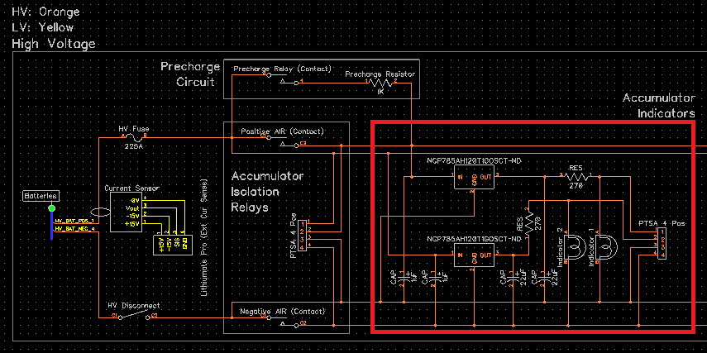

Figure 15 - Accumulator indicator schematic

## Charging

*Describe how the accumulator will be charged. How will the charger be connected? How is the accumulator to be supervised during charging?*

The accumulator will be charged through a dedicated Anderson Powerpole charging connector. Additionally, a separate on/off wire will be connected to the AMS, allowing for the AMS to directly turn off and on the charger. Additionally, the AMS will have its fault line connected to a relay that controls the AC input to the charger as a secondary safety measure. The accumulator will be supervised by the RSO or alternate RSO during charging. Additionally the individual cell voltages and temperatures can be supervised through a wireless adviser that is connected to the AMS.

*Complete the table*

|  |  |
| --- | --- |
| Charger Manufacturer and model: | Elcon PFC5000 |
| Maximum charging power: | 5 kW |
| Isolation | Yes /  No |
| UL Certification (If “no”, fill in the line below) | Yes /  No |
| Do you have a waiver from the FH rules committee? | Yes /  No |
| Maximum charging voltage: | 300 V |
| Maximum charging current: | 7.5 A |
| Interface with accumulator (e.g. CAN, relay etc) | Relay |
| Input voltage: | 115 VAC single phase |
| Input current: | 20 A |

Table 20 - Charger data

## Accumulator Container/Housing

*Describe the design of the accumulator container. Include the housing material specifications and construction methods. Include data sheets for insulating materials. Include information documenting compliance with UL94-V0, FAR25 or equivalent.*

The accumulator container was designed to meet EV3.4 of the Formula Electric rules which outlines the design of a steel accumulator box. The bottom and sides of the box are welded together out of 4130 steel, with the top bolted to this piece. Kapton tape is used to insulate where necessary, such as near the edges of the pouch cells. Additionally, Stratasys RGD525 plastic is used to house the pouch cell connections, insulating them and preventing vibrations.

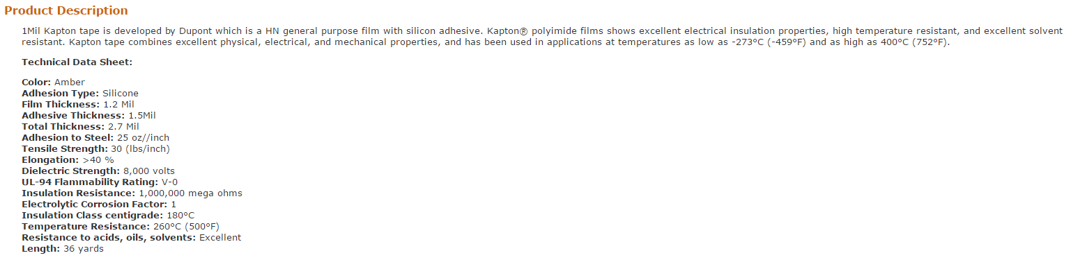

Figure 16 - Kapton tape product description

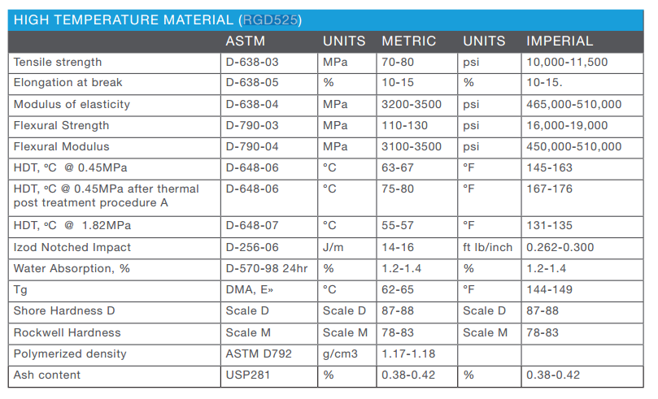

Figure 17 – RGD525 high temperature plastic datasheet

*If the housing is made of conductive material, include information on how the poles of the accumulators are insulated and/or separated from the housing, and describe where and how the container is grounded to the chassis.*

The poles of the accumulator are insulated from the accumulator using Kapton tape on the inside of the accumulator. The entire container is bolted to the chassis, and is therefore grounded through those bolts.

*Include additional photographs if required to comply with rule* ***EV3.2.***

N/A

*Show how the cells are mounted, use CAD-Renderings, and include calculations showing compliance with FH Rules* ***EV3.4.***

The largest cell stack is of 22 cells, and therefore has a maximum voltage of:

3.65V x 22 = 80.3V

And a maximum energy of

20Ah x 3.3V x 22 = 1452kWh = 5227.2MJ

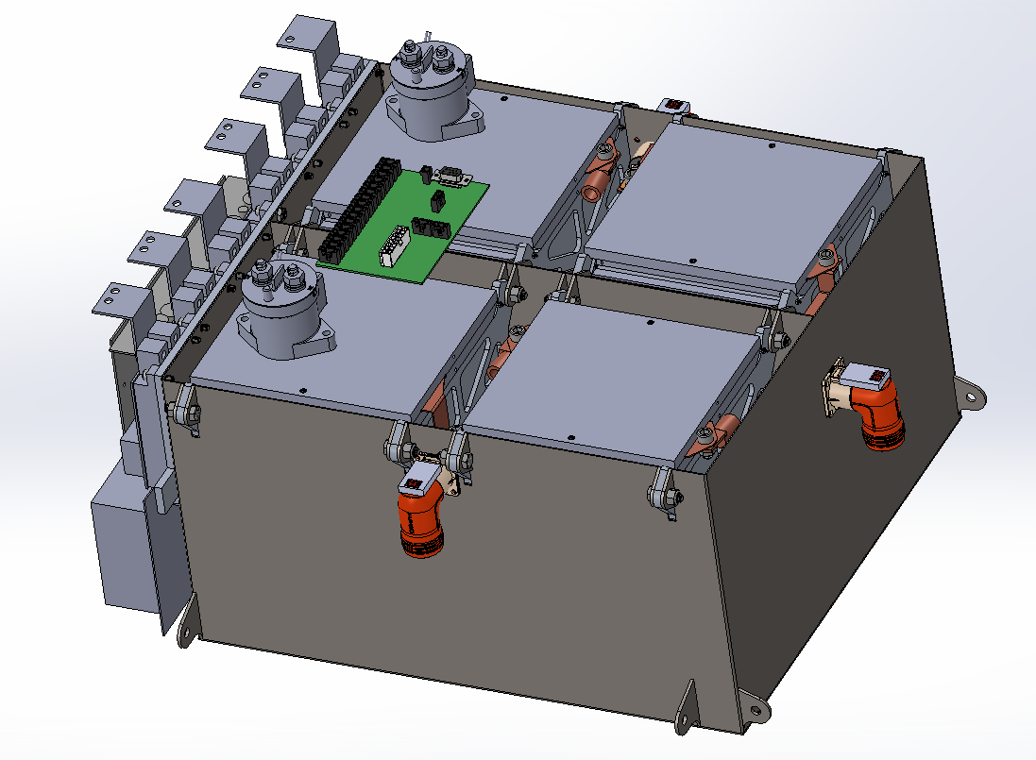

Figure 18 – Accumulator stack configuration

# Safety Controls and Indicators

## Shutdown Circuit

*Include a schematic of the shutdown circuit for your vehicle including all major components in the loop*

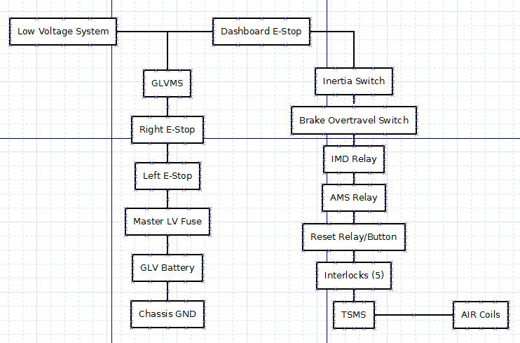

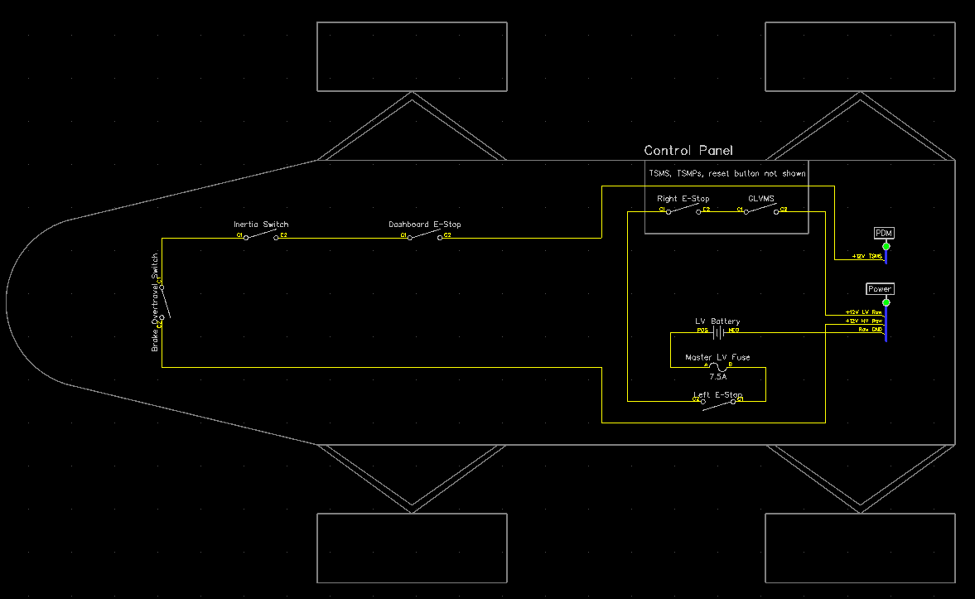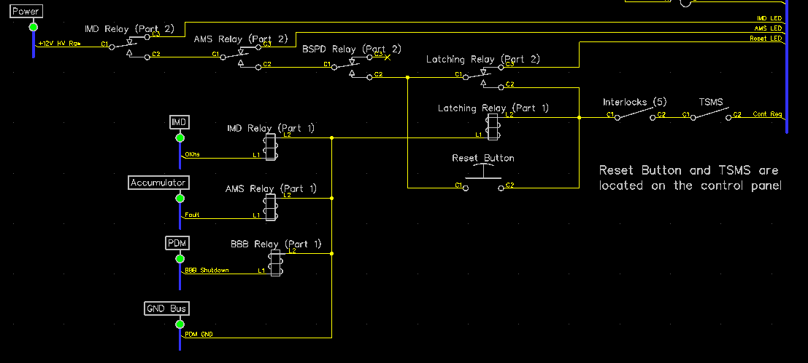

Figure 19 – Safety Shutdown Circuit Schematic

*Describe the method of operation of your shutdown circuit, including the master switches, shut down buttons, brake over-travel switch, etc. Also complete the following table*

|  |  |
| --- | --- |
| **Part** | **Function  (Momentary, Normally Open or Normally Closed)** |
| Main Switch (for control and tractive-system; CSMS, TSMS) | Normally Open |
| Brake over-travel switch (BOTS) | Normally Open |
| Shutdown buttons (BRB) | Normally Open |
| Insulation Monitoring Device (IMD) | Normally Open |
| Battery Management System (AMS) | Normally Open |
| Interlocks (if used) | Normally Open (SMD and HVD) |

Table 21 - Switches& devices in the shutdown circuit

*Describe wiring and additional circuitry controlling AIRs. Write a functional description of operation*

The AIRs are directly controlled by the AMS. If the AMS discovers a fault, then it opens the AIRs and closes the discharge relay. Additionally if an AIR welds shut then an interlock switches a relay such that the shutdown circuit turns the tractive system off.

|  |  |
| --- | --- |
| Total Number of AIRs: | 2 |
| Coil holding current per AIR: | 0.13 A |
| Current drawn by other components wired in parallel with the AIRs. | 0 A |
| Total current: | 0.26 A |

Table 22 - Shutdown circuit Current Draw

*Provide CAD-renderings showing the shutdown circuit parts. Mark the parts in the renderings*

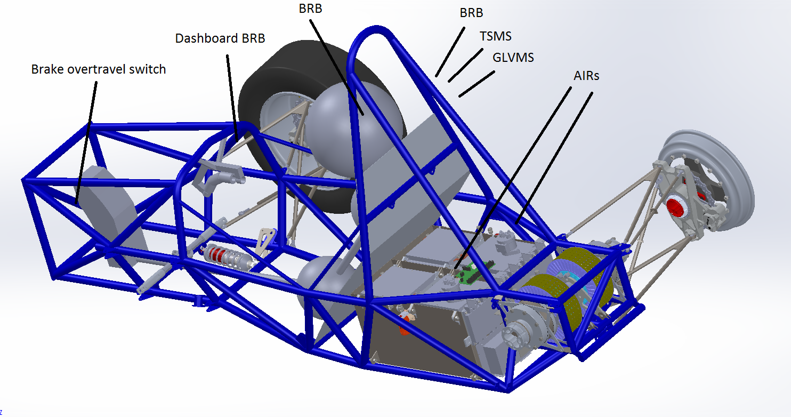

Figure 20 – Location of Shutdown Circuit Components

## IMD

*Describe the IMD used and use a table for the common operation parameters, like supply voltage, temperature, etc. Describe how the IMD indicator light is wired. Complete the following table.*

|  |  |
| --- | --- |
| MFR / Model | Bender IR155-3204 |
| Set response value: | 200 kΩ (666.7 Ω/Volt) |

Table 23 Parameters of the IMD

*Describe IMD wiring with schematics.*

The IMD is powered from the +12V DC bus line on the car. Its relay is connected in series with the high voltage part of the shutdown circuit such that it can turn off the tractive system whenever a fault is detected.

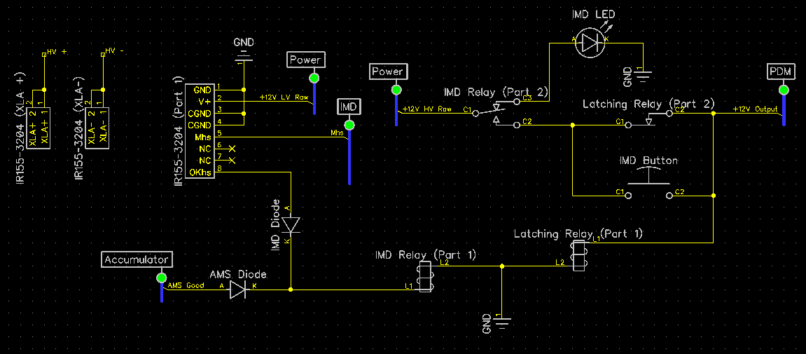

Figure 21 – IMD schematic with latching relay

## Reset / Latching for IMD and AMS

*Describe the functioning and circuitry of the latching/reset system for a tripped IMD or AMS. Describe wiring, provide schematics.*

The IMD is wired to a latching relay and button such that the button actuates the latching relay. The button is a momentary push button and the relay is non-latching, but the circuit is setup such that the relay will latch when the button is pressed if the IMD OKhs is high signaling a safe car. If the IMD were to detect a fault, OKhs would go low, turning off the latching relay. This could only be reset by the button after OKhs goes high again. The button is located out of reach of the driver so that the driver cannot reset an insulation fault. Refer to figure 16.

## Shutdown System Interlocks

*(If used) describe the functioning and circuitry of the Shutdown System Interlocks. Describe wiring, provide schematics.*

The AIR interlocks measure the voltage between the positive and negative poles of each AIR. This is passed through an instrumentation amplifier gain stage, to an optoisolator, and then used to determine if the AIR is welded shut. If it is, then a relay in the shutdown circuit is opened to turn off the tractive system.

## Tractive System Energized Light (TSEL)

*Describe the tractive system energized light components and method of operation. Describe location and wiring, provide schematics. See* ***EV4.10***

The TSEL is an amber light that is powered by the tractive system through a DC-DC converter that steps down 300V to 12V. Refer to figure 4.

## Tractive System Voltage Present light (TSVP)

*Describe the tractive system voltage present light components and method of operation. Describe location and wiring, provide schematics. See* ***EV4.12***

The TSVP lamps are amber lights that are powered by the tractive system through a DC-DC converter that steps down 300V to 12V. They are visible whenever the tractive system bus voltage is between 100V and 300V. Refer to figure 4.

## Ready-To-Drive-Sound (RTDS)

*Describe your design for the RTDS system. See* ***EV4.11***

Our microcontroller controls a Mallory Sonalert buzzer through an N-channel MOSFET such that the buzzer makes noise for two seconds when the tractive system is enabled.

# GLV System

Person primarily responsible for this section:

|  |  |
| --- | --- |
| Name: | Philip Piper |
| e-mail: | philip.piper@yale.edu |

## GLV System Data

*Provide a brief description of the GLV system and complete the following table*

The GLV system is designed to be simple this year. Rather than getting too far into data acquisition, we are focusing on getting a vehicle that runs well. Additionally a CAN bus will likely be used in this year’s design

|  |  |
| --- | --- |
| GLV System Voltage | 12 V |
| GLV Main Fuse Rating | 7.5 A |
| Is a Li-Ion GLV battery used? | Yes /  No |
| If Yes, is a firewall provided per **T4.5.1**? | Yes /  No |
| Is a dc-dc converter used from TSV? | Yes /  No |
| Is the GLV system grounded to chassis? | Yes /  No |
| Does the design comply with **EV1.2.7**? | Yes /  No |

Table 24- GLV System Data

# Appendices

Include only highly-relevant data. A link to a web document in the ESF text is often more convenient for the reviewer.

The specification section of the accumulator data sheet, and sections used for determining accumulator capacity (FH Rules **Appendix A**) should be included here.

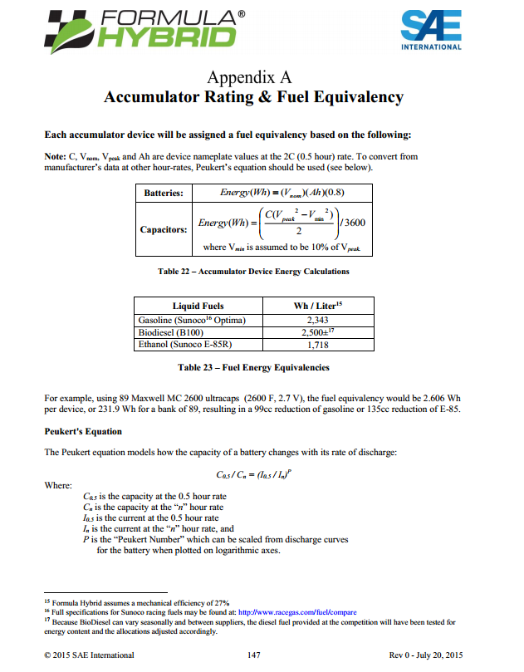

Figure 22 – Appendix A of Formula Hybrid rules

1. Calculate accumulator capacity per 2016 FH Rules Appendix A. Be sure to use the 2C (0.5 hour) discharge rate for the Ah value.